**Supplementary Requirement Release 2- Team3**

1. CN – Connectivity

**Scope:**

* UC02.01 Ad Content
* UC02.02 Ticket Sales
* UC03.02 User Relationship
* UC04.03 Modify General User's Information

**Requirements:**

* System should retain caches to populate values, if the front-end is disconnected due to Network issue, or some error.
* System should also show a popup window with an error message, “Connection failed, please try again later”.

**Conditions to Apply:** After the respective join points.

1. ExH - Exception Handling

**Scope:**

* UC03.02 User Relationship
* UC04.04 Contact a Customer Support

**Requirements:**

* If system fails to submit the form to contact customer support then error msg should be displayed saying “Something went wrong, please try again”.

**Conditions to Apply:** After the respective join points.

1. SI-In System Interface (inbound)

**Scope:**

* UC01.01 Content variability
* UC02.01 Ad Content

**Requirements:**

* Data fields that are coming in from external api are ‘movie id’, ’poster’, ’overview’, ’rating’ and are directly displayed to user. If movie ID does not match with fetched movie info then display “System failed to fetch movie data, please refresh the page or try again letter”.
* Ad in an image format comes in from the third party advertisers like google AdSense. If system fails to load these ads then display alternative default ad about MLDB on that space.

**Conditions to Apply:** After the respective join points.

1. SI-Out - System Interface (outbound)

**Scope:**

* UC02.02 Ticket Sales

**Requirements:**

* When user clicks buy tickets show notification saying, “you will be directed to partner website, click ok to proceed” and if user clicks ok then redirect.

**Conditions to Apply:** After the respective join points.

1. DF-In - Data Flow In

**Scope:**

* UC03.02 User Relationship
* UC04.05 Delete an Account

**Requirements:**

* As shown in the Data Flow Diagram below User data is flown in from user table for UC03.02 and UC04.05.

**Conditions to Apply:** After the respective join points.

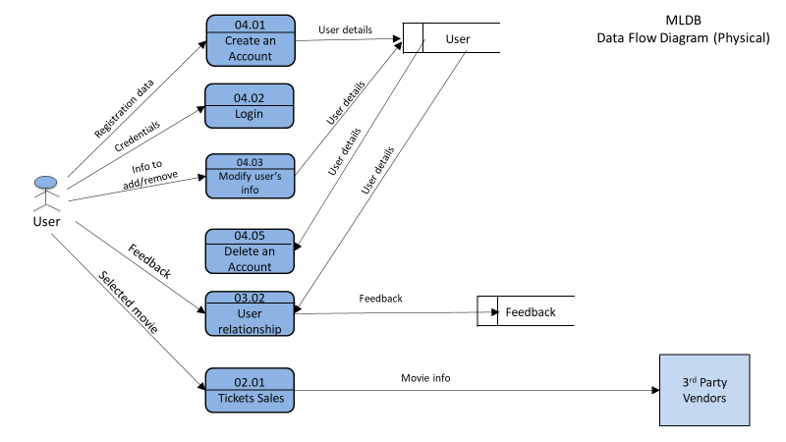

1. DDV - Data-Dependency Validation

**Scope:**

* UC04.03 Modify General User's Information

**Requirements:**

* If entered zip code does not match state field then display “please enter valid zip”.